**DATA MINING PROJECT REPORT**

**Name: Aqsa Rahman**

**Roll number: i191908**

**Section: DS-N**

**K-Elbow Visualization:**

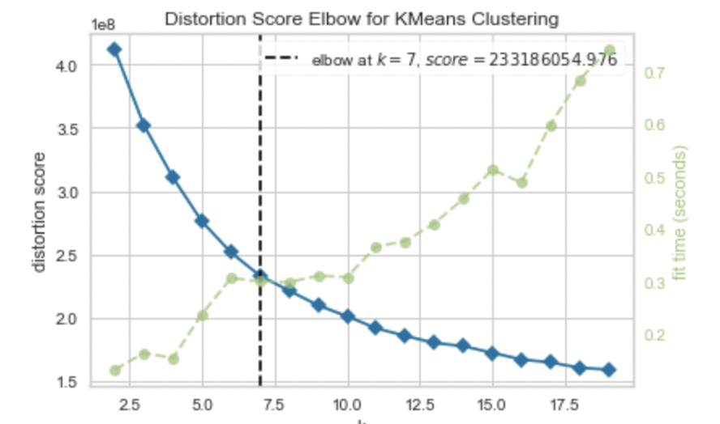

**Segmented Images:**

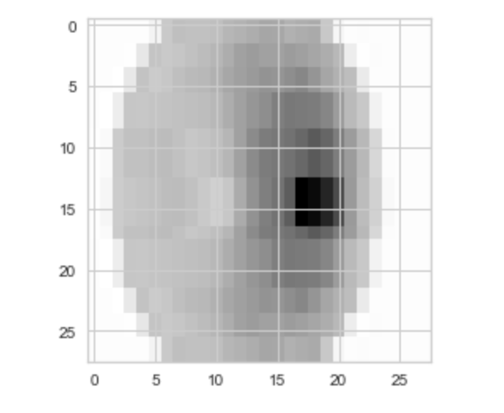

**Conclusion of different models:**

**ML model Logistic Regression (non-segmented images):** Selected 68% of the data as train and rest of the data as test. The accuracy achieved through this model on the test is 41.07 %.

**ML model Logistic Regression (segmented images):** The accuracy achieved through this model on the test is 41.07 %.

**Conclusion**: Logistic Regression performed same on both non segmented and segmented images.

**ML model naive Bayes (non-segmented images):** Selected 68% of the data as train and the rest as test data. The accuracy achieved through this model on the test was 33.92%.

**ML model naive Bayes (segmented images):** The accuracy achieved through this model on the test is 33.928%.

**Conclusion:** Naive Bayes performed same on non-segmented images and segmented images.

**ANN model (segmented images):**  Implemented the Simple neural network with 3 layers and Adam optimiser and 10 epochs. The accuracy achieved through this model was 68%.

**ANN model (non-segmented images)**: Implemented the Simple neural network with 3 layers and Adam optimiser and 10 epochs. The accuracy achieved through this model was 55%.

**Conclusion:** ANN performed better on segmented images with an accuracy of 68%.

**CNN model ( segmented images):** Implemented the Simple neural network with 3 layers and Adam optimiser and 10 epochs. The accuracy achieved through this model was 66%.

**CNN model (non-segmented images):** Implemented the Simple neural network with 3 layers and Adam optimiser and 10 epochs. The accuracy achieved through this model was 68%

**Conclusion:** CNN performed better on non-segmented images with an accuracy of 68%.

Time Graph (Segmented vs Non-Segmented):

.